**Changes to existing entities**

1. Remove the Alternator Type entity
2. **tAlternator**
   1. Add the below fields
      1. AlternatorFamilyID
      2. VoltagePhaseID
      3. FrequencyID
      4. VoltageID

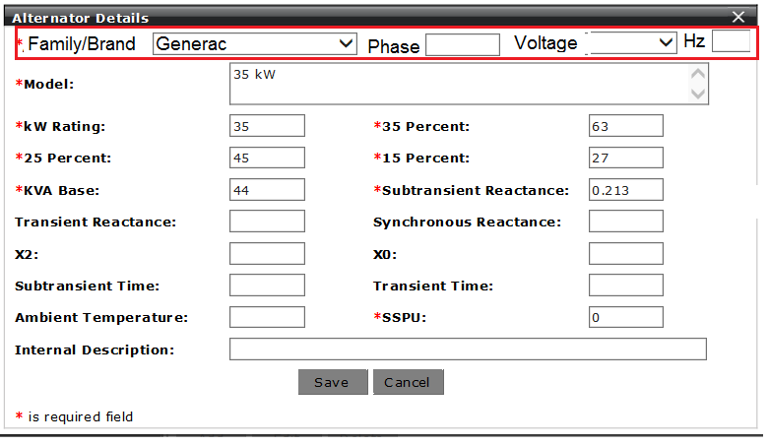

1. **New - tGeneratorAvailableAlternator**
   1. Add the below fields
      1. ID
      2. AlternatorID
      3. GeneratorID
      4. CreatedBy
      5. CreatedDateTime
      6. ModifiedBy
      7. ModifiedDateTime
2. **tGenset**
   1. Remove the below fields
      1. Is50HzAvailable
      2. AvailableVoltageCode
      3. MaximumAlternatorUpSize
   2. Add
      1. FrequencyID
3. **tGeneratorAvailableVoltageNominal**
   1. Add the below fields
      1. ID
      2. GeneratorID
      3. VoltagePhaseID
      4. CreatedBy
      5. CreatedDateTime
      6. ModifiedBy
      7. ModifiedDateTime

**Load Summary**

1. For each Product Family,
   1. Set a priority to each family.
   2. Loop through the families by the priority order for a product recommendation available in that family.
2. Filter the Product Family by the following logic
   1. ~~Fuel Type – Might need to associate product families to Fuel Type.~~
   2. Brand? – Might filter for Pramac version.
   3. Find all the generators with the Fuel Type == Fuel Type from solution setup and get the product families for the generators.
3. For the filtered Product Families,
   1. Loop through each family
      1. Get MaxKW generator in the family using the below conditions
         1. Firstly, filter the generators in the family by below and then order by KWStandby descending.
            1. Generator.Frequency == SoltuionSetup.Frequency
            2. Generator.VoltageNominal == SoltuionSetup.VoltageNominal
            3. Generator.AvailableFuelType == SolutionSetup.FuelType
         2. For the filtered generators, from the list of alternators tied to the Generator(from tGeneratorAvailableAlternator table), find an alternator by applying the below conditions
            1. Conditions

Alternator.Phase == SolutionSetup.Phase

Alternator. Frequency == SolutionSetup.Frequency

Alternator. VoltageNominal == SolutionSetup. VoltageNominal

* + - * 1. then order by KWRating desc
        2. pick the 1st alternator from the list.
    1. Check for some conditions (**please verify the code in old PDP application**) on the MaxKW generator to see if the family can provide a recommended product.
       1. Function Name -
    2. Filter the generators in the family by,
       1. Non-MPS
          1. Conditions

Generator.ProductFamilyID == ProductFamilyID

Generator.Frequency == SoltuionSetup.Frequency

Generator.VoltageNominal == SoltuionSetup.VoltageNominal

Generator.AvailableFuelType == SolutionSetup.FuelType

Generator.PrimePowerAvailable == IIF(EngineDuty == Prime, 1, 0).

* + - * 1. Then order by KWStandby ascending.
    1. For the generators list from above step,
       1. If there are some generators in the list,
          1. Find a generator by applying the same conditions that are applied on the MaxKW generator. (Function name - findGensetRow)
          2. Pick the 1st generator that satisfies the conditions.
          3. For the generator picked above, we have a list of alternators

Order the list by KWRating ascending.

Pick the optimal alternator using some conditions (**please verify the code in old PDP application**). Function name - findAlternatorRow

* + - 1. Else, there is no solution available.

**MPS Logic:**

1. If we don’t find a solution in a Single family, move to the MPS family
2. If SizingMethod is AUTO,
   1. If, IsMPS family and FamilySelectionMethod not MANUAL,
      1. Filter the generators by
         1. Generator.ProductFamilyID == ProductFamilyID
         2. Generator.Frequency == SoltuionSetup.Frequency
         3. Generator.VoltageNominal == SoltuionSetup.VoltageNominal
         4. Generator.AvailableFuelType == SolutionSetup.FuelType
         5. Generator.PrimePowerAvailable == IIF(EngineDuty == Prime, 1, 0)
      2. For